Order No: 105 of 2025
Dated: 06-10-2025
Subject: Directions for Registration on JK Samadhan - A Dedicated Grievance Redressal Portal.
In pursuance of the Government Order issued by the Office of the Deputy Commissioner, Srinagar, regarding registrations on JK Samadhan, All Faculty (Permanent, Academic Arrangement, and Guest), Staff, and Students of the institution are hereby directed to register on the JK Samadhan Portal at the earliest.
This Portal is a Unified Grievance Redressal & Monitoring System, empowering Citizens of Jammu and Kashmir to register and track their grievances and subsequent redressal. Registration on the Portal is mandatory.
Registration Process:
- Access the Registration Link: https://samadhan.jk.gov.in/login OR
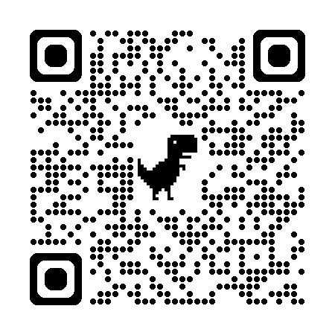
Scan QR

- After clicking on the link, click on "Registration" and fill your details to complete the registration process.
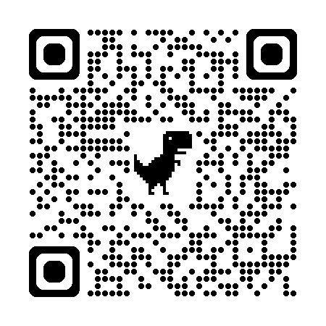
- After successful registration, fill the given Google Form link: https://forms.gle/tSDhfKRxA5Ufftqh6 OR Scan QR

Video Demonstration Guide is also available on the link: https://www.facebook.com/share/v/1F8Ga3wcvx/

Important Note: All Heads of Departments (HODs)/Incharges/Faculty should ensure that all Students are registered on the portal and mark class attendance only after verifying the registration status of the student. They should also ensure that the required details are also provided on the Google Form. Review meeting related to the registrations will be taken by this week.
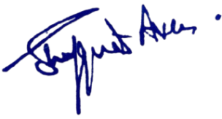
The Incharge Accounts shall check the registration status of all Employees of this institution before the disbursal of the salaries for the month of Oct-2025.
For any support, contact on 9906457756.
No: No: KGP/Estt/2025/1258 D Dated:06-10-2025

Dr. Shafquat Ara
Principal
Kashmir Govt.Polytechnic College Srinagar
Copy to the:
- Concerned for information and compliance.

